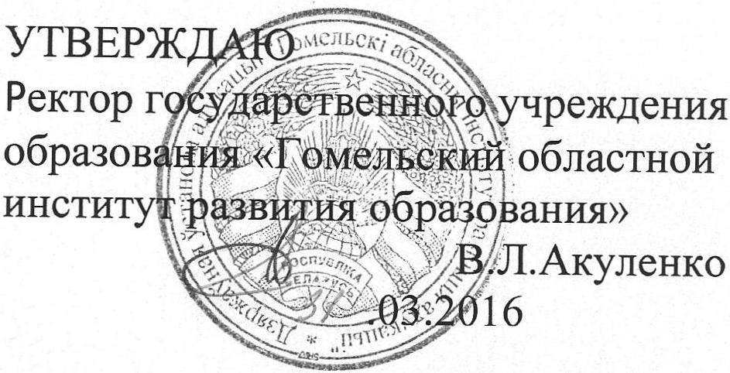
Задания второго этапа областной олимпиады учащихся 4-9 классов
по английскому языку
2015/2016 учебный год
6 класс

Максимальное количество - 50 баллов

Part А. Read the text and do the following tasks.
My name is Ben and I come from Australia. I am 24 years old and I live in a small town near Sydney called Branton.
I don't have a job now, but normally I clean shop windows. I am not married but I live with my very beautiful girlfriend, Maria, in a nice house in Branton. We don't have any children - maybe next year.
My girlfriend is an actress, but she isn't very famous. She acts in a small theater in our town. At the weekend, we like to go swimming in a big lake near our house.
I normally get up at eight o'clock, but on Thursday I get up at six o'clock because that is the day when I go running in the park.
I like living in Branton because it's not too big. There are some historical buildings in the center of the town and near Branton, there is a river where I go fishing sometimes when I want to relax.

- Answer True or False for the questions below (8 points):
- Ben comes from Australia but lives in America.___________
- Ben has a job as a window cleaner. ___________
- Ben isn't married. ___________
- Ben and Maria are having a baby next year. ___________
- Ben's girlfriend works in a local theater. ____________
- Ben gets up early once a week to do some sport. ___________
- Ben thinks that Branton is too small. ___________
- Ben goes swimming in a river near Branton. ___________

- Use ONE word to complete each answer about the reading (10 points):
- He comes from ___________________.
- He's ___________________years old.
- Ben lives in ___________________.
- No, he ___________________.
- Her name is___________________.
- No, they___________________.
- They live in a ____________________.
- She is an ___________________.
- They go___________________ in a lake.
- He goes running on___________________ mornings.
Английский язык. 6 класс. Стр. 1 из 2.

Part В. Lexical-Grammar Test.

- Fill in the gaps with a, the. If there is no article, write “–” (5 points):
- Please clean ________ blackboard.
- It’s as cold as ________ ice.
- Which is longer: _______ Volga or ______ Dnieper?
- They say ________ sugar is bad for you.

IV. Choose the correct preposition (4 points):
- They arrived ______ Scotland successfully.
- to b) in c) from
- Usually Mr Parker was a careful driver, stopping _______ every crossroad.
- on b) in c) at
- The meeting was put off ______ Thursday.
- to b) till c) after
4. He looked _____ the newspaper quickly before going to work.
a) through b) at c) after

V. Choose the correct form (4 points):
- Do you know how far ______ from here to school?
a) it is b) is it c) there is
2. ______ anything interesting in yesterday’s news programmes.
a) It wasn’t b) There wasn’t c) There was
3. I think ______ important to speak a foreign language.
a) there was b) is c) it is
4. If ____ is hot in the room, you can open the window.
a) it b) there c) –

VI. Read the text and put the verbs in the right tense form (12 points):
The first commercial television broadcast (1. make) ___________________ on April 20, 1939. Since 1939, it (2. become) ___________________ one of the most important facts of modern life.
Television (3. be) ___________________ very much a part of the modern world. Its effects (4. feel) _____________ all over the world.
Television (5. show) ________________ contemporary society, (6. say) ________________ some people. Television (7. be) __________________ bad for culture because it (8. keep) ___________________ culture from growing, (9. say) ___________________ still others.
Good or bad, television (10. be) ___________________ in our homes. Its pictures (11. enter) _______________ houses, airports, stores and even schools. It (12. be) ________________ to stay!

VII. One word in each following sentence is wrong. Take it away and write the correct one
(7 points):
- He’s taking the medicine, doesn’t he? ______________________________________________
2. Dan said that the sun were shining brightly that day. ____________________________________
3. Mr Watson also has a very high opinion of herself._____________________________________
4. He is having a bath when Jack came. ________________________________________________
5. She said Edward how much she missed her cousin. ____________________________________
6. Fortunately, the news are not so sad. You can tell her.___________________________________
7. I couldn’t make a cake because there were no any eggs.__________________________________
Английский язык. 6 класс. Стр. 2 из 2.

