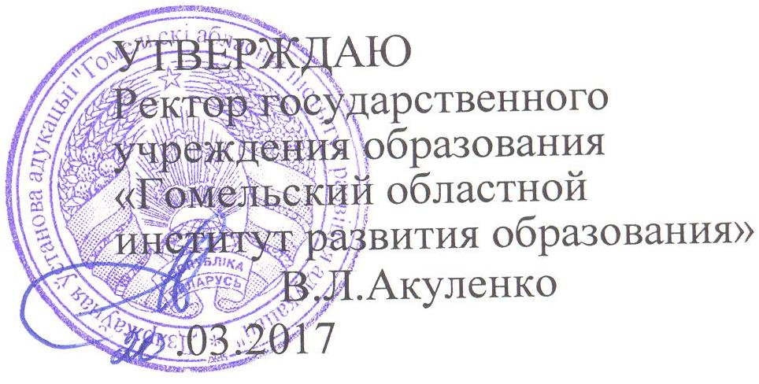

Задания второго этапа областной олимпиады учащихся IV-IX классов
по учебному предмету «Английский язык»
2016/2017 учебный год
VII класс

Максимальное количество – 60 баллов
Part А.
I Read the texts and questions bellow carefully. Choose the best answer A, B, C or D (5 points):
Almost all civilizations have their own tales of giants. Giants are the oldest creatures to live on the Earth. They are of enormous size and strength compared to ordinary humans. In Albanian tales, giants are as tall as trees and have long black beards that hang down to their knees. Some giants are kind and gentle while others can be very cruel. Irish giants are pleasant creatures, English giants can be very evil and Welsh giants are clever.
In Germanic and Scandinavian tales, giants or trolls can be either friendly and helpful or nasty creatures, but they are always frightening. They can take the form of any animal they choose whenever they like and people believe that they cause storms, hurricanes and even earthquakes. We see them living in castles or under bridges where they force travellers to pay money to pass. American folk tales describe how Paul Bunyan, a giant lumberjack who makes lakes and rivers whenever he wishes, creates the Black Hills and the Grand Canyon. He is a symbol of strength and energy.
Are giants simply fairy tale characters? Scientists have found gigantic skulls and huge jaws which they say belong to giants who were on the earth half a million years ago. Moreover, there are many stories of sightings of mysterious giant creatures. Many people believe that there is a giant human-like creature, the Yeti or Abominable Snowman, living somewhere in the Himalayas. Others talk of Bigfoot, a large, dark, hairy giant with enormous feet, that lives somewhere in the Canadian wilderness. They say it is at least 2.2 metres tall.
Giants fascinate people and appear in many stories, old and new, but the mysteries of certain giants such as the Yeti may be more than just a fairy tale.
- In this text the author is describing…
A different civilizations.
B real stories.
C large creatures.
D fairy tales.
- According to the text, some giants…
A are not very strong.
B can be quite nice.
C are taller than trees.
D live for a long time.
- What is the general description, according to the author, of giants in Germanic and Scandinavian tales?
A They are friendly.
B They are nasty.
C They are helpful.
D They are scary.
- What have scientists found?
A Large skeletons millions of years old.
B Very large bones.
C Proof that giants never existed.
D Large animals living in the Himalayan mountains.
- The author believes that
A giants existed a long time ago.
B it's silly to believe such stories.
C giants still exist but we haven't seen them.
D some of the stories may be true.

II Look at the word in the bold in the text and choose the synonym to it (1 point):
- far from normal, b) noisy, c) huge

Part В. Lexical-Grammar Test.
I Correct the mistakes (8 points):
1.Who invented America?__________________________________________________________________
2. There are 10 fingers on my foot.______________________________________________
3. Please remember me to take it._______________________________________________
4. Are you fond of football play?_______________________________________________
5. Give me the others sweets.__________________________________________________
6. We ate dinner with no desire.________________________________________________
7. Don’t loose our money.____________________________________________________
8. Are there much pupils absent?_______________________________________________
II Complete the sentences with the correct preposition (7 points):
I'm working ___________a hospital now. I applied __________ a nurse's job last May and started ____________July. Of course it's very hard work looking ___________the patients, but I knew it would be like that when I decided_________________ the job. I just try to forget all the problems and concentrate ___________ the job. I think it's a worthwhile thing to do, and I'm sure you'll agree _________________ me.
III Choose the right variant (8 points):
1. Terry felt the snake ... his foot.
a) to touch b) to touching c) touch
2. Why not... a little party to mark the occasion?
a) to have b) have c) to having
3. I hope you don't mind ... the dog with me.
a) my bringing b) me to bring c) me bring
4. He got malaria ... travelling in Africa.
a) as b) during c) while
5. Niagara Falls are worth ....
a) to see b) seeing c) to be seen
6. I don't want... with my problems.
a) him interfere b) he to interfere c) him to interfere
7. Young children grow up ... these days.
a) fastly b) in a fastly way c) fast
8. She isn't as happy ... she used to be.
a) than b) as c) like
IV Complete the sentences using the appropriate derivatives of the words in capitals (8 points)
1. Our marks for the test were rather_________________. DISAPPOINT
2. Some parts of the Amazon are more than 190 kilometres in__________. WIDE
3. You will find science lessons active and _______________________.VARY
4. His joke was rather weird and there followed a(an) ______________ silence. COMFORT
5. I don`t think that _____________________ is right in any situations. VIOLENT
6. He got angry because we _________________________ with him. AGREE
7. It`s very_______________________to chew a chewing gum in public. POLITE
8. Mrs. Read isn’t satisfied with my results. She says I`m a _______________ student. CARE
V Rewrite the sentences using the word in bold (6 points)
1. It's really important you don't arrive late. better
You________________________________________________late.
2. They crossed the Atlantic in three days. them
It__________________________________________________cross the Atlantic.
3. He lived in London once, but he doesn't any more. used
He _____________________________________________________in London.
4. When did she come back? since

5. David can play the violin well. good
David________________________________________________.
6. He is expected to come tonight. It
___________________________________________________ tonight .
VI Insert the right article where necessary (a/an, the, -) (8 ponts):
1. He fell in love with her at ___________ first sight.
2. ______Dublin Airport is situated about 12 kilometres from _______ city centre.
3. “Which newspaper do you want?” ___________ “Herald”.
4. ________ Statue of Liberty is at the entrance to _________ New York Harbour.
5. When was __________ telephone invented?
6. I have ___ problem. Can you help me?
VII Use the correct tense-forms of the verbs in brackets (9 points)
I (always, be)___________ afraid of fires because when I (be)____________ eight years old, my boarding school (burn) ______________down. The flames (be)_________________ hundreds of metres high and (reach)__________________ up into the night sky. By the time the fire brigade (arrive)_______________, the building (nearly, burn)____________________ down and there (be)______________ very little they (can)____________________ do.

