**Test “My house”**

1. **Write the English equivalents**

Ванная комната______________

Зал_______________

Коридор_____________

Кухня___________

Ложки, вилки и ножи_____________________

Тарелки и кружки________________

Холодильник_______________

Шкаф для посуды и шкаф для одежды____________________________________

1. 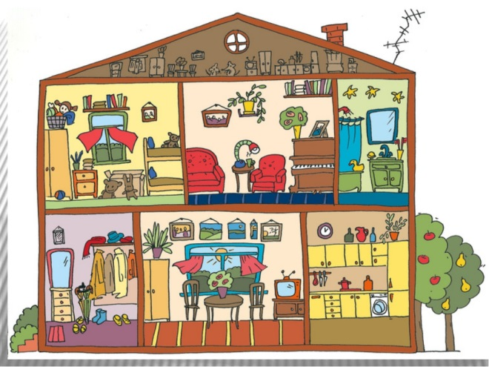**Describe the house. Use *there is/there are***

*Model: There is a mirror in the hall*

1. **Fill in with *there is* or *there are***

**________________** nice flowers in the room.

________________ a red book on the table.

________________ chairs near the table.

_________________ a mouse in the garden.

__________________ books in the bag .

_________________ balls under the table .

_________________ a mirror in the bedroom.

__________________ pens on the book.

__________________ two rooms in the house.

___________________some sandwiches in the fridge.

___________________a cake on the plate.

___________________some jam on the table.

___________________some cornflakes in the cupboard.

___________________some sweets in the fridge.

___________________two cups of tea on the table.

1. **Translate the sentences**
2. В коридоре есть зеркало
3. На верхнем этаже есть две спальни
4. В зале есть маленький стол
5. На кухне есть несколько стульев
6. В доме есть ванная комната
7. На кухне есть газовая плита
8. **Describe your own house or flat**