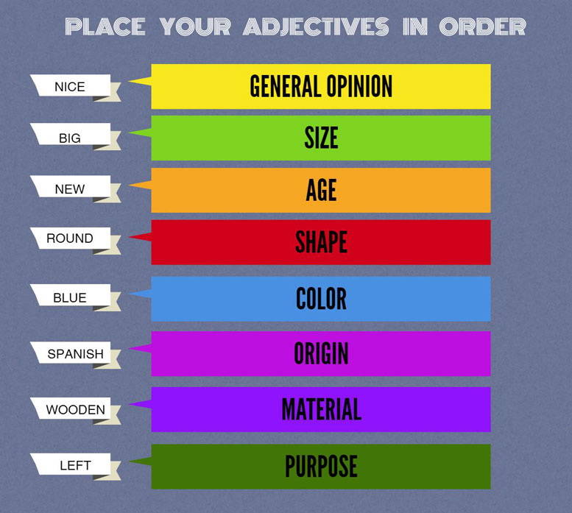

Put the following into the correct order
1) suede / French / blue / soft / shoes
2) young / tall / Englishman
3) oval / Venetian / antique / valuable / glass
4) expensive / shiny / large / yellow / leather / case
5) oval / wooden / modern / nice / table
6) large / stone / beautiful / cottage
7) porcelain / tea / blue / thin / cup
8) tall / handsome / young / blonde / man
9) English / old / several / beautiful / castles
10) young / pretty / a lot of / French / girls
11) dark blue / best / silk / my / shirt

- My teacher is a(n) (English, kind, middle aged, short) lady.
- Can you introduce me to the (British, tall, young, pretty) girl?
- My grandmother is a(n) (elderly, easy- going, short, Russian) woman.
- Mr. Brown is a(n)( elderly, intelligent, French, tall) teacher.
- Sandy is my (middle-aged, patient, kind, British) colleague.
- Boris Schwartz is the (German, young, tall, brilliant) tennis play.
- Rudolf Diesel is the (famous, German, cleverest) scientist.
- Shura is the (Russian, strange, tall, middle –aged) singer.

