Test “Films”
- Match the word with its definition
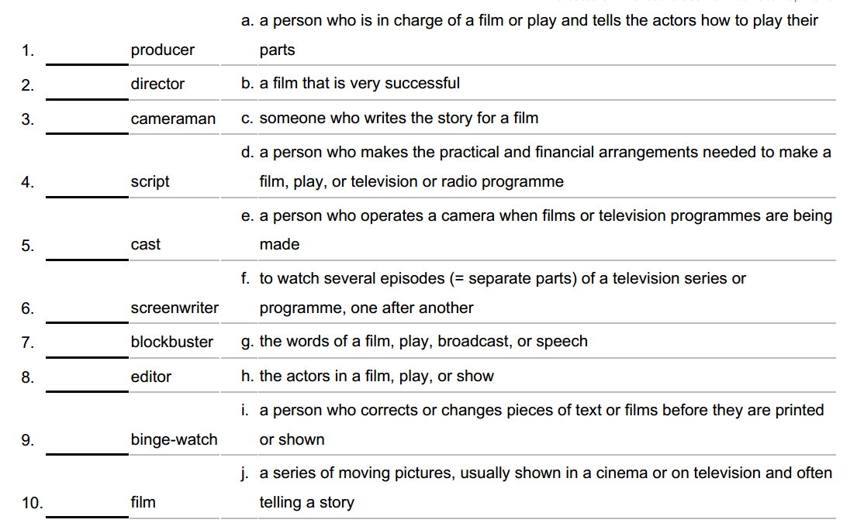
- Fill in the prepositions
- Our business has been going … all winter
- There's nothing … television tonight.
- More and more people are shopping … the Internet.
- The Lumiиre brothers showed 10 short films in front of paying customers in a Paris hotel for the first time … 28 … December …1895
- I prefer watching films … streaming websites.

