TEST “Customs and traditions”
- Match the word with its definition
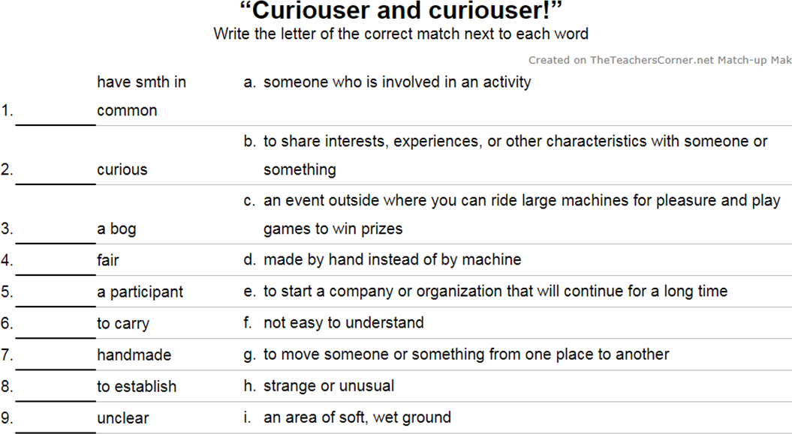
- Fill in the prepositions
- … midday we shut the shop for lunch.
- The country is poor … natural resources.
- I'm the luckiest man … the world!
- A dark house can draw attention … the fact that the house is empty.
- The island is rich … bird life.
- The two games have much … common.
- The floor was covered … dust.
- I don’t like bread spread … butter.
- She crossed her fingers … luck.
- He played a trick … me.

- Read the definition to the word and choose the most suitable one to complete the meaning
- Fancy dress - the special clothes that you (hold, involve, wear) for a party where everyone dresses as a particular type of character or thing
- Participant - a person who (takes part, watches out, establishes) in or becomes involved in a particular activity

- Change the word adding suffix or prefix
- John, - Oh! You’re a … !!! prank
- The terms (условия) of the contract are very … clear
- It's … to predict the future. possible
- The facts were … to us. know
- I wasn't a … in the preparations, merely a spectator. participate
- …, you were out when we called. fortune

- Give the synonym to the following word
- Yearly
- Pay attention to
- To play a joke on
- In the afternoon
- Joy
- Lamp
- Nosy
- Start

- Give the antonym to the following word
- To be rich in
- Real
- For bad luck
- Best clothing
- A clear lake
- A good sport

- Translate the sentences
- Я хотел бы обратить ваше внимание на этого любопытного мужчину!
- Все деньги пойдут на благотворительность.
- Он был на седьмом небе от счастья, потому что не попался на его розыгрыш
- У нас с братом нет ничего общего.
- Он шёл передо мной, с фонарём в руках.

