**Lexical-grammar test 14**

1. ***Fill in the suitable word***
2. She will definitely … progress in this sphere.

Why did she do a thing like that? It doesn't seem to … sense.

1. Close your eyes and … a wish.

If you wish to … a complaint, you should see the manager

1. It's a good idea to … some research before you buy a house.

We will … the shopping for you.

1. It took her a long time to … a decision.

The expression “to … fun of” means *“to ridicule.” (насмехаться)*

1. I usually get up early and … some housework.

He rarely *consents (соглашаться)* to … interviews.

1. We've only got one day in Paris, so we'd better … the most of it.

Jenny has always found it easy to … friends at school.

1. … me a favour - turn the radio down, will you?

*The rumours (сплетни)* will … untold damage to his reputation.

1. … a list of all the things you have to do.

You can … a young fortune on that deal

1. She usually  … the laundry and hangs it out to dry.

She … stretching exercises before her daily run.

1. ***Find the extra word in each line***

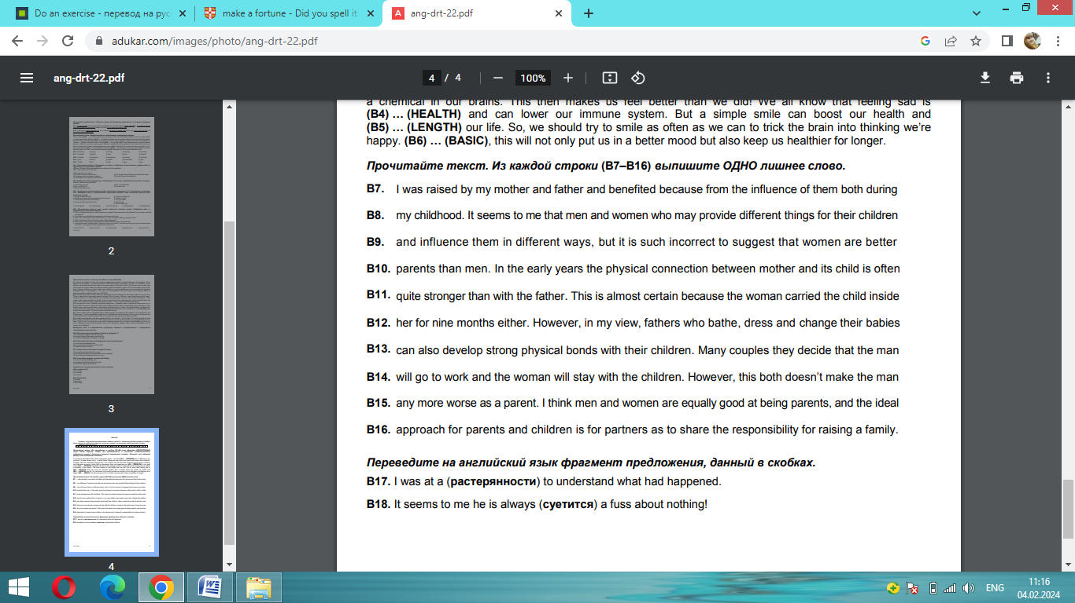

1. ***Complete the sentences using the correct form of the words***
2. Each man will be paid according to his … able
3. His work is… original. true
4. Civil war has been … the country for years. threat
5. Arthur was a very gentle, … person. care
6. ***Fill in the prepositions***
7. … theory, the scheme sounds fine.
8. He was accused … murder.
9. Let's try to have a calm discussion … your grades.
10. I don't like talking … public.
11. The policeman signalled to him to pull …
12. I guarantee to pay … all the money.
13. The children were all … tears.
14. Did she do this … purpose, was it all just a game, an act?
15. He has no intention … leaving the political stage.
16. I mistook him … his brother.
17. Most soldiers are only boys … uniform.
18. He asked leave to speak to her … private.
19. My recent cold has pulled me ….
20. She was quick to point … my errors.
21. ***Fill in the articles where necessary***
22. "In … other words, it has haunted you."
23. The wax melted in … sun.
24. There was a big truck in … way.
25. "Can we speak privately?" she said in… low voice.
26. It is much cooler in … shade.
27. ***Choose the suitable variant***
28. Are you married, …, or divorced? (alone, lonely, single)
29. She felt … and insecure away from her family. (alone, lonely, single)
30. I want to be … (alone, lonely, single)
31. 57 miners were buried … (living, alive, live, lively)
32. She is a true … legend. (living, alive, live, lively)
33. The program was shown … (living, alive, live, lively)
34. She was a nice round … little girl. (living, alive, live, lively)
35. You can download updates for … (vacant, free, empty, deserted, abandoned)
36. Have you a room …? (vacant, free, empty, deserted, abandoned)
37. The streets were … (vacant, free, empty, deserted, abandoned)
38. The house has sat … for two years. (vacant, free, empty, deserted, abandoned)
39. That house was … years ago. (vacant, free, empty, deserted, abandoned)

