Fill in the prepositions where necessary
- I live … 10 Tverskaya street
- He lives … Lenin street.
- I'll find … your secret.
- There's a short poem (стих) … the beginning of every chapter (глава).
- Cut a hole (отверстие) … the middle of the paper.
- We're doing a project … healthy lifestyle
- The house is … the end of the road.
- I am reading a good book … history
- The smaller animals can easily jump … tree …tree.
- My hotel room looks … across the lake.
- I am looking … my glasses.
- Who's going to look … the children when you're at work?
- The book is very popular … children.
- We'll be staying … the Hotel Plaza
- I'd love to go on … holiday somewhere where it's nice and quiet.
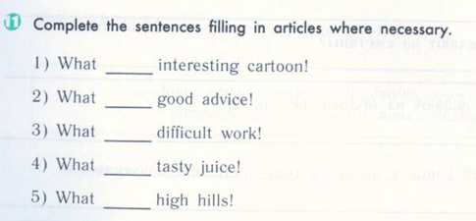
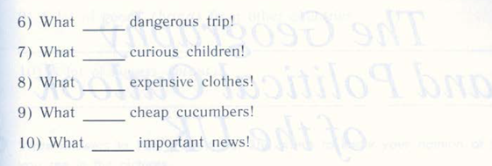

- She … stalked out (вышла) of the room angry
- They are fishing in … waters. Canada
- I do not speak … France
- He is learning to speak … China
- There are a lot of … bison in Belovezhskaya Pushcha Europe

