VIII FORM
LEXICAL-GRAMMAR TEST

I. Complete the text with the correct forms of the verbs in brackets.
Ronald and Mary 1_______(drive) along a quiet country road in Southern England. They 2_______(be) on the way to Westberry. It 3_______(be) nearly midnight. "Ron! Look over there! There 4_______(be) something in the sky. What 5_______(be) it?" — "I 6_______(not know) what it 7_______(be). It 8_______(be) probably a plane." — "I 9_______(not think) so, it 10_______ (be) too big and too bright." — "Oh, no!" — "What's the matter?" — "The engine 11_______ (stop)."— "Why 12____it_______ (stop)?"— "I 13_______(not know). I must 14_______(find) a garage. 15_______(be) there one near here?" — "Yes, there 16_______(be) one in the next village. I 17_______ (not be) sure if it 18_______(be) open. It 19_______(be) very late." Suddenly there 20_______(be) a loud noise and a big bright silver object 21_______(fly) low over their car. It 22_______(stop) in mid-air,_______(loom) round, then 24_______(fly) straight up into the sky and 25_______(disappear).
"Oh, Ron! What 26_______(be) that?" — "27_______(not ask) me. I 28_______ (have got) no idea what it 29_______(be)." — "I 0_______(frighten). Let's go." — "We can't. The engine 31_______(work)." — "32_______(try) it again." — "That 33_______ (be) strange! It 34_______(be) OK now. I 35_______(wonder) why it 36_______(not work)." — "37______you_______(think) it 38_______(be) a UFO?" — "I 39_______(not know). I really 40_______(not know). We 41_______(phone) the police." — "Ron! 42______you_______(think) they 43_______(believe) us?"
II. Complete the sentences with the correct prepositions.
1. Don't look_______me! I am not guilty.
A. for B. after С at
2. If I get_______early, I'll do a lot of necessary things.
A up B. on C. off
3. Put_______ the fire. We must go back.
A on B. aside С out
4. Is our plane taking_______ now?
A. off B. out С in
5. Who turned_______ the page of my book?
A. over B. up С off
6. He called_______ my returning back in time.
A. in В for С out
7. I was in despair. My father came _______in the world.
A again B. back С down
8. It runs _______to the time when I was a schoolgirl.
A. off В back С after
9. He gave himself _______to be an artist. We didn't believe them.
A. out B. back С away
10.1 wonder what's going _______here?
A. at B. on С by
III. Arrange the words in pairs of synonyms.
1. realize a) fine
2. wealth b) riches
3. announce c) offer
4. immediately d) pick up
5. talk e) understand
6. suggest f) at once
7. lift g) point
8. spot h) declare
9. excellent i) chat
10. memorial j) monument
11. question k) place
IV. Identify the meaning of the word in caps.
1) You must KEEP your promise.
А. сдержать В. хранить
С. охранять D. соблюдать
2) Не KEEPS on interrupting.
А. держать В. содержать
С. охранять D. продолжать
3) His jokes MADE us laugh.
А. сделали В. произвели
С. заставили D. смогли
4) I hope you will not CHANGE your mind.
А. изменишь В. променяешь
С. выменяешь D. оставишь
5) I'm not interested in your OPINION.
А. представление В. мнение
С. взгляд D. воззрение
V. There are eight mistakes in the following text in the use of sequence offenses. Find them and correct.
When I approached the house I was hearing the scream. I rang the doorbell several times. When the woman at last opened the door I had understood that something unusual has happened. She was trembling. She told me that she has seen someone's shadow in the sitting room. I rushed to the kitchen to grab a knife. I thought it is a thief. The woman told me that it is on the table. So with the knife in my hand I entered the sitting room. I turned the light on. And I see there is a nice small squirrel jumping from one curtain to another.
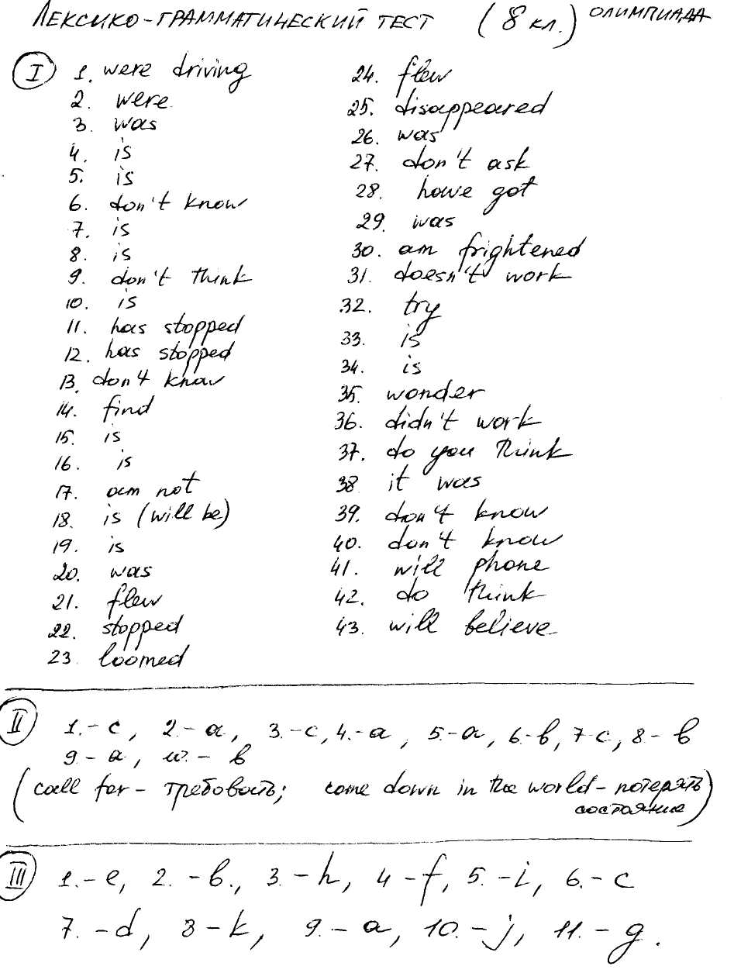
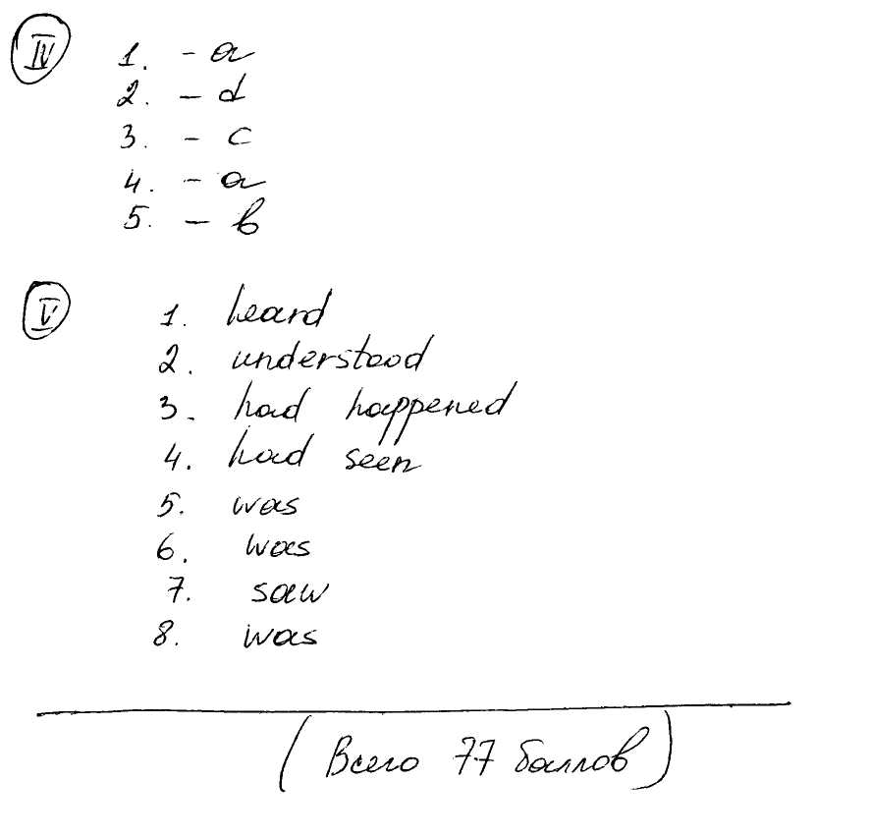

V FORM
LEXICAL- GRAMMAR TEST

Task I. A. Choose the right variant
One - oneth/ first
Two - twoth/ second
Three - threeth/ third
Four ~ fourth/ frith
В. Put this or these where necessary
books, ... hair, ...school,... pets

Task II. Use necessary pronouns:
our, their, your, his, her, its, my
1) Peggy and Ann are riding _____ bicycles.
2) Bob and Jane, please sit down and do______homework,
3) Mike is phoning_________friend.
4) Lena and I are helping _ father in the garden.
5) 1 like____new teacher of English.
6) My friend has a squirrel at home._________tail is very long!
7) He does_______morning exercises every day.
8) She helps ______mother about the house on Sundays.

Task III. Write the words in the singular or in the plural
One moon - some_____________
One_______some cats
One bird some ________
One _ - some brushes
One glass - some ____________
One _ - some berries
One pair of trousers - some_______________
One______________~ some children

Task IV. A. Make the sentences from these words
1) Thomas's/ today/ it/ birthday/ is.
2) Bought/ cake / and/ a/ nine/ Mum/ candles.
3) Friends/ Thomas/ presents/ his/ got/from.
4) At/ the/ children/ table/all/ are sitting/ the.
B. Ask the questions to the following sentences
1) My flat is on the ground floor.
2) There is a small garden in front of my house.
3) I wasn't at school yesterday.
4) Her little brother is playing in the yard now.

Task V. Translate the sentences from Russian into English
1) Дети едят торт и пьют лимонад.
2) Они хотят танцевать.
3) Дети поздравили Томаса с Днем рождения.
4) Томас счастлив.

7th form
GRAMMAR TEST
I Choose the right variant:
1. There is no further/ farther information about your flight.
2. He is the oldest/ eldest child.
3. Your house is two miles further/ farther from here than mine.
4. Our friends arrived more late/ later than we expected.
5. Do you know the latest/ last news?

II Complete the sentences. Use the passive (present or past) of these verbs:
blow build clean damage find invent make
make pay show speak steal
1. The house ... every week.
2. Two trees ... down in the storm last night.
3. Furniture ... from wood.
4. There was a fire at the hotel last week. Two rooms ...
5. Many different languages ... in the world.
6. These houses are very old. They ... many centuries ago.
7. Many American films... on British television.
8. 'Is this a very old film?1 'Yes, it ... in 1949.'
9. My car........ last week. The next day it... by the police.
10. The transistor ... in 1948.
11. She has a very good job. She... £ 3000 a month.

III Open the brackets and put the verbs into the proper tense form.
One day my friend Holmes and I were smoking in our room after supper when Mr Lestrade came in. He often 1____(visit) us as he 2____(can) always 3_____(get) some help from Holmes, and my friend 4_____(listen) with interest to all his stories and 5____(be) ready 6_____(give) him advice.
"Dear gentlemen," Lestrade 7_____(say), "I 8_____(like) 9_____(discuss) with you a very strange case, though perhaps it 10_____(interest) Dr Watson more than you, Mr Holmes. There 11_____(be) a man, who 12_____(hate) Napoleon so much that he always 13____(break) his statues. Some months ago a doctor 14____(buy) two statues of Napoleon and after that he 15____(go) to the country when he 16_____(come)back he 17_____(see) they 18_____(disappear)." "Your story 19_____(begin) 20_____(interest) me," 21____(say) Holmes.

IV Correct the mistakes.
1. The monkey is one of the funniest animal in the world, isn't it?
2. Cinderella asked her stepmother could she go to the ball.
3. They asked the princess why was she crying.
4. He said that they will like the palace.
5. Winnie the Pooh said Piglet that he wanted to find honey.
6. There was a beautiful flower in the garden. There was the best
flower in the world.
7. She said that she met them before.
8. Neither Betty nor Susan met nobody there.
9. Why is Mrs White look so angry? What has happened?
10.1 have never been to London. - So have I.
11. He said that he will visit his grandparents the next day.
12. She tells that these: newspapers are bought every day.

V Read the sentences and write them in the indirect form:
1. Sasha said, "I do my morning exercises every day."
2. "Where is Tanya?" the teacher asked the pupil on duty.
3. The pupil asks the teacher, "Shall I go on reading?"
4. Victor said, "Can you swim, Oleg?"
5. Dima says to his little brother, "Do not open that box!"
6. "Do you know Natasha's address?" Nina asked her friend.
7. Lena says, "I have had a good time in the country."
8. Kolya said, "I am doing my homework."
9. Tonya said, "The weather is changing now."
10. Vera Ivanovna says, "Look after your sister, Natasha."
11. The postwoman asks the man at the door, "Are you Mr. Brown?"
12. The woman says to her little daughter, "Don't cross the street when the light is red."

7th form
GRAMMAR TEST (KEYS)
I Choose the right variant:
1. There is no further information about your flight.
2. He is the eldest child.
3. Your house is two miles further/ farther from here than mine.
4. Our friends arrived later than we expected.
5. Do you know the latest news?

II Complete the sentences. Use the passive (present or past) of these verbs:
1. is cleaned
2. were blown down
3. is made
4. were damaged
5. are spoken
6. were built
7. are shown
8. was made
9. was stolen, was found
10. was invented
11. is paid

III Open the brackets and put the verbs into the proper tense form.
1. visited
2. could
3. get
4. listened
5. was
6. to give
7. said
8. would like
9. to discuss
10. will interest
11. is
12. hates
13. breaks
14. bought
15. went
16. came
17. saw
18. had disappeared
19. begins
20. to interest
21. said

IV Correct the mistakes.
1. The monkey is one of the funniest animals in the world, isn't it?
2. Cinderella asked her stepmother if she could go to the ball.
3. They asked the princess why she was crying.
4. He said that they would like the palace.
5. Winnie the Pooh told Piglet that he wanted to find honey.
6. There was a beautiful flower in the garden. It was the best flower in the world.
7. She said that she had met them before.
8. Neither Betty nor Susan met anybody there.
9. Why is Mrs White look angry? What has happened?
10. I have never been to London. - Neither have I.
11 .He said that he would visit his grandparents the next day. 12.She says that these newspapers are bought every day.

V Read the sentences and write them in the indirect form:
1. Sasha said that he did his morning exercises every day.
2. The teacher asked the pupil on duty where Tanya was.
3. The pupil asks the teacher if he can go on reading.
4. Victor asked Oleg if he could swim.
5. Dima tells his little brother not to open that box.
6. Nina asked her friend if she knew Natasha's address.
7. Lena says she has had a good time in the country.
8. Kolya said he was doing his homework.
9. Tonya said that the weather was changing then.
10. Vera Ivanovna tells Natasha to look after her sister.
11. The postwoman asks the man at the door if he is Mr. Brown.
12. The woman tells her little daughter not to cross the street when the light is red.

6th form
Lexical-grammar test
I.Fill in the pronouns: some, any; no+ body, thing.
1. Have you____to drink?
No, I have____.
2. He is reading____very interesting in the newspaper.
3. All are present.____is absent.
4. There are____sheep in the yard. Count them , please.
5. There aren't____exercise-books on the desk.

II. Choose the correct variant of the sentence:
1. a) We already made a campfire. b) We made a campfire yesterday.
2. a) He has just bought the ticket to Moscow. Here it is! b) He just bought the ticket to Moscow.
3. a) I have been to a concert this week, b) I was at a concert this week.
4. a) The children did their homework. They can play.
b) The children have done their homework. They can play.
5. a) Robert came back today.
b) Robert has come back today.

III. Ask questions to the sentences:
1. Life is beautiful. (Special: What)
2. We must wear school uniform at school. (General)
3. After classes he plays foot-ball. (Tag-question)
4. She has just missed her train. (Alternative)
5. There is much noise in this classroom. ( General)

IV. Fill in adverbs or adjectives:
1. You look so ( beautiful/beautifully)
2. This lady never works ( quickly/quick)
3. Look at this little girl. She is so ( sweet/sweetly)
4. Thank you very much. It's so ( kind/kindly) of you.
5. She always studies new words ( easily/easy)
6. She has got a cold. She feels (bad/badly)

V. Complete the sentences with prepositions:
1. He never goes__car, he always goes__foot.
2. When we lived__the seaside last year we stayed__the hotel.
3. He is waiting for me__the bus stop.
4. We decided to meet__the railway station.
5. Have you bought a ticket__London?
6. When are you going __ a journey?
7. He is never tired__playing the computer.
8. He saw his friend__board the ship.

VI. Open the brackets and use the correct form of the verb:
1. ___they (to paint) the walls yet?
2. Look at these children: they (to skate) very well.
3. You (to go) to Great Britain last year? - No, I (to go) to France.
4. What your brother (to do) now?
5. Where you (to put) house keys? I can't find them anywhere.

