Yanka Kupala Gymnasia Name
The 2nd semester Form 6

Task I Conversation Choose the right variants( 5points):
1) What is he? | a) He enjoys comics and theatre.
2) What is he like? | b) Fine, thanks.
3) What does he like? | c) He is my school friend.
4) What does he look like? | d) He is a student from Australia.
5) Who is he? | e) All right.
6) How is he getting on? | f) He is a tall fair-haired boy.
7) Would you please give me his telephone number? | g) He is a kind and polite young man.

Task II (6points):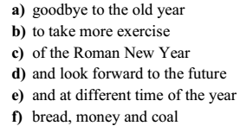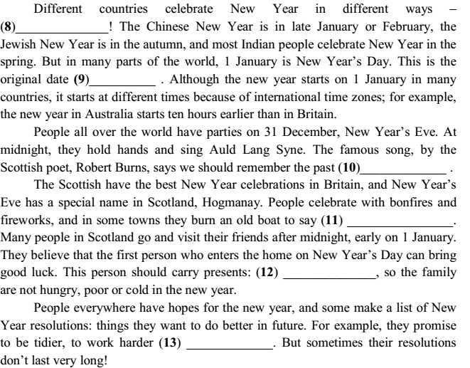
Task III Find the mistake in every phrase (12 points):
14) Ms.Compton was a high man with a pleasant voice.
15) The news aren’t very good, I’m afraid.
16) That plant smells rather terribly.
17) We can’t help you because we don’t speak English very good.
18) What is the long of the hall in your flat?
19) Both Pat as David are interested in detective films.
20) She knows anything about his trip to Scotland.
21) Santa Claus has nine reindeers and a sleigh.
22) Neither Jess nor Trisha are fond of gardening.
23) Please, divide the sweets between those three kids.
24) Who can speak what has happened?
25) Janet used to had very long hair.

Task IV Tense-forms in the brackets (12 points):
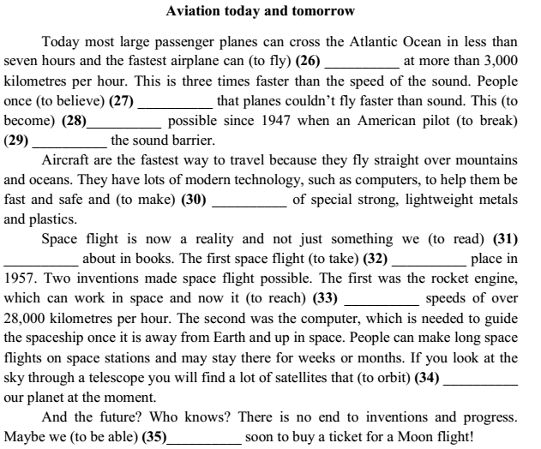

Task V. Use the right form of the word (5points)::
36. Arabic is a language in Egypt (nation).
37. The weather is often in this part of the world. (change).
38. We always feel the of the sun in spring (warm).
39. Mrs. Collin has already bought a new for her Christmas tree (decorate).
40. I’m .Can I have a glass of water, please? (thirst).
41. I think you are wrong. It is to grow bananas in Europe (possible)

Task VI.Fill in the right article or no article at all (6 points):
42. Would you like green tea or black coffee?
43. Can you tell me way to Belarusian Drama Theatre?
44. Have you got any post card with Victory Square and Pripyat?

Task VII.Fill in the right preposition (4points):
45. They live 15 High Street.
46. The train is going the tunnel.
47. When I was walking the bank, I saw Jill.
48. We made friends university.

